# 

# ****Travel Sphere: A Comprehensive Travel and Tourism Management System****

## ****1. Abstract/Keywords****

### ****Abstract****

Travel Sphere is an advanced travel and tourism management system designed to streamline operations, enhance customer experiences, and optimize travel-related services. This report explores its background, problem statement, technical specifications, database design, program structure, implementation, testing, limitations, and future scope.

### ****Keywords****

Travel Sphere, Tourism Management, Travel Technology, Booking System, AI in Tourism, Smart Travel, Digital Tourism, Travel Automation.

## ****2. Introduction to the Project****

### ****2.1 Background****

The travel and tourism industry has undergone a significant transformation with the integration of digital technologies. Travel Sphere is designed to provide seamless booking, itinerary management, and customer support using AI-driven solutions. The system aims to enhance efficiency, reduce manual workload, and improve customer satisfaction.

### ****2.2 Problem Statement****

Traditional travel management systems often suffer from inefficiencies, lack of personalization, and fragmented services. Travel Sphere addresses these challenges by offering an integrated, AI-driven solution that ensures smooth travel planning, real-time updates, and personalized recommendations.

## ****3. Software and Hardware Requirement Specification****

### ****3.1 Methods:****

**Agile Development Methodology** – Ensures iterative improvements and adaptability.

**AI-Based Recommendation Engine** – Provides personalized travel suggestions.

**Cloud-Based Infrastructure** – Enables scalability and remote access.

### ****3.2 Programming/Working Environment:****

**Programming Languages:** Python, JavaScript, SQL.

**Frameworks:** React.js for frontend, Django for backend.

**Cloud Services:** AWS or Google Cloud for hosting.

**Operating Systems:** Windows, macOS, Linux.

### ****3.3 Requirements to Run the Application****

**Minimum Hardware Requirements:**

**Processor:** Intel i5 or higher.

**RAM:** 8GB or more.

**Storage:** 500GB SSD.

**Internet Connectivity:** Required for real-time updates.

**Software Requirements:**

**Database Management System:** MySQL or PostgreSQL.

**Web Server:** Apache or Nginx.

**Development Tools:** Visual Studio Code, GitHub.

## ****4. Database Analyzing, Design, and Implementation****

### ****Database Type****

**Relational Database Management System (RDBMS)** – MySQL or PostgreSQL.

### ****Database Tables****

**Users:** Stores user details and preferences.

**Bookings:** Manages reservations and payments.

**Destinations:** Contains travel locations and packages.

**Payments:** Tracks transactions and billing details.

### ****Implementation****

**Normalization:** Ensures efficient data retrieval.

**Security Measures:** Encryption and authentication protocols.

## ****5. Program’s Structure Analyzing and GUI Constructing (Project Snapshots)****

### ****Frontend Design****

**User-Friendly Interface:** Intuitive navigation and interactive dashboards.

**Responsive Design:** Compatible with mobile and desktop devices.

**Features:** Booking system, itinerary planner, customer support chat.

### ****Backend Architecture****

**Secure API Endpoints:** RESTful services for data exchange.

**Authentication System:** Multi-factor authentication for security.

### ****Project Snapshots****

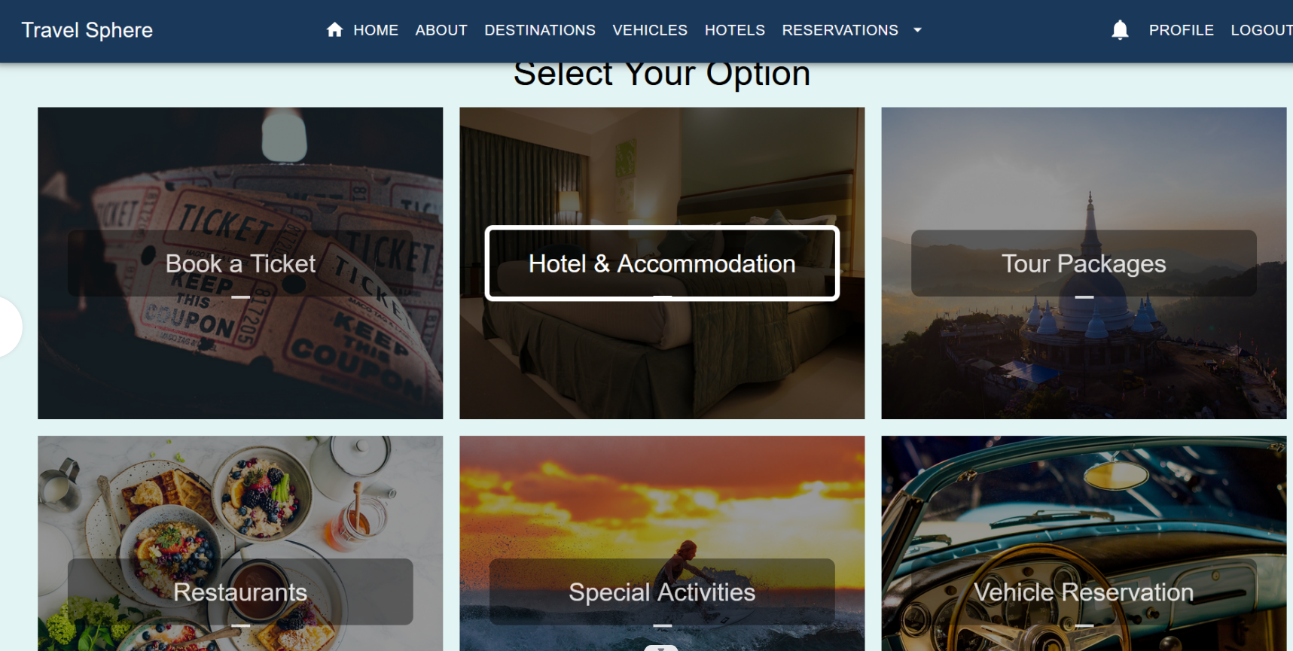

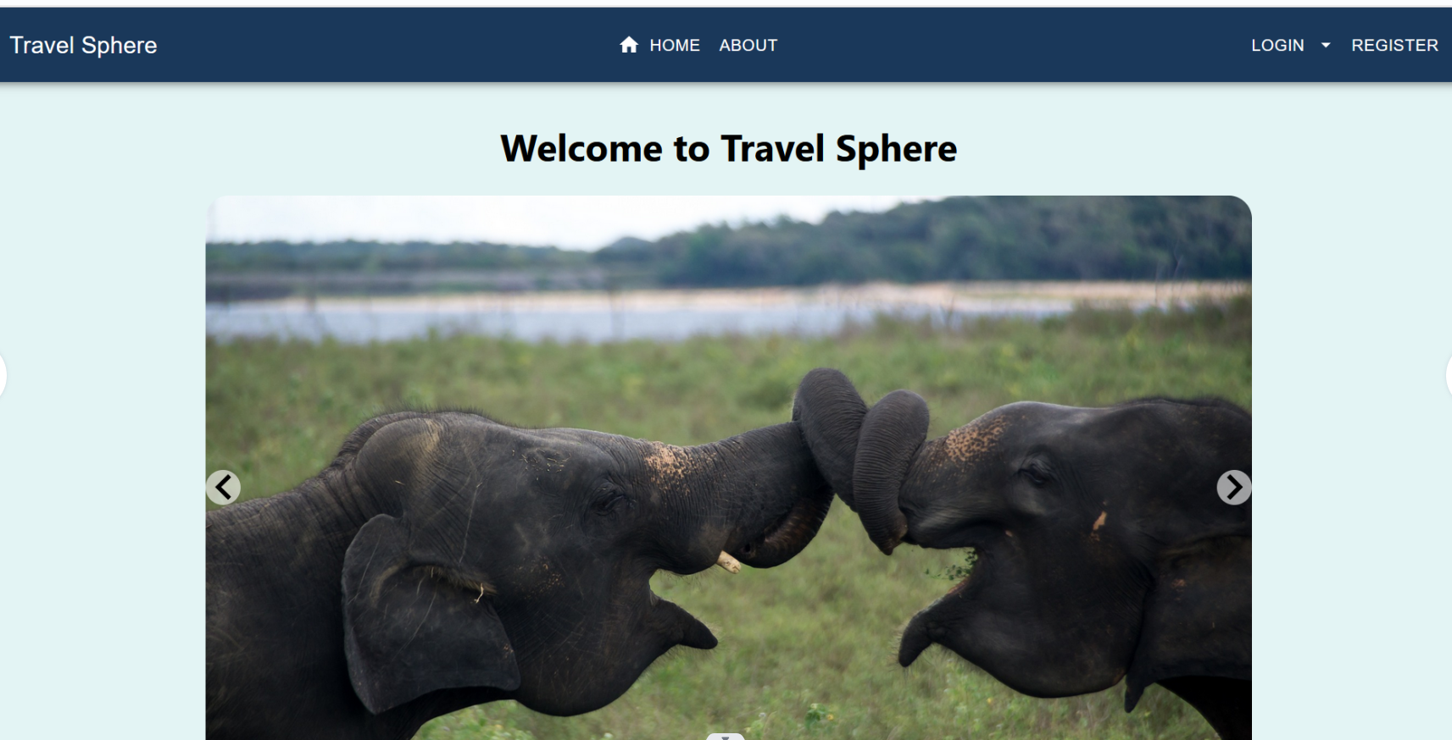



## ****6. Code-Implementation and Database Connections****

### ****Backend API****

**RESTful API:** Facilitates communication between frontend and backend.

**Data Encryption:** Ensures secure transactions.

### ****Database Connection****

**Secure Authentication:** Uses OAuth or JWT tokens.

**Optimized Queries:** Reduces response time.

## ****7. System Testing****

### ****Testing Methods****

**Unit Testing:** Ensures individual components function correctly.

**Integration Testing:** Verifies seamless interaction between modules.

**User Acceptance Testing:** Gathers feedback for improvements.

**Performance Testing**

**Load Testing:** Evaluates system performance under high traffic.

**Security Testing:** Identifies vulnerabilities and strengthens protection.

## ****8. Limitations****

**Internet Dependency:** Requires stable connectivity.

**Initial Setup Costs:** Cloud hosting expenses.

**Data Privacy Concerns:** Requires robust security measures.

## ****9. Conclusion****

Travel Sphere revolutionizes travel and tourism management by integrating AI, automation, and data analytics. It enhances customer experiences, optimizes operations, and ensures seamless travel planning.

## ****10. Future Scope****

**Blockchain Integration:** Secure transactions and fraud prevention.

**Virtual Reality-Based Travel Experiences:** Immersive destination previews.

**AI-Driven Chatbots:** Real-time assistance and customer support.

## ****11. Bibliography/References****

Chatgpt

Google Chrome

Github